**Objects And Its Internal Representation In Javascript**

In JavaScript, an object is a standalone entity, with properties and type. Compare it with a cup, for example. A cup is an object, with properties. A cup has a color, a design, weight, a material it is made of, etc. The same way, JavaScript objects can have properties, which define their characteristics.

**Creating Objects in JavaScript:**

1. By object literal
2. By creating instance of Object directly (using new keyword)

**By object literal:**

The syntax of creating object using object literal is given below:

Property and value is separated by colon(:).

**Example:**

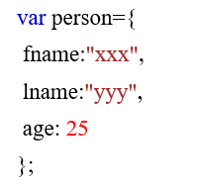

**By creating instance of Object directly (using new keyword):**

The syntax of creating object directly is given below:



Here, **new keyword** is used to create object.

**Example:**

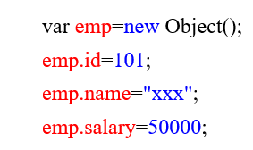

**Accessing JavaScript Objects:**

The syntax for accessing the property of an object is: *objectName.property* (or) *objectName*[“*property*”]

Accessing using dot operator,



Accessing using [],

